
Company
Logotype

Cone Beam Computed Tomography- Report



Porur Dental X-rays & CBCT

Patient Name : Master. Kavin | Date of Report : 30.06.2024
Age/ Gender : 8 years/ Male | Region of Interest : CBCT Maxilla
Referring doctor: Dr. Anjan Kumar | Indication : Impacted tooth
Clinical Notes: Nil
PATIENT INFORMATION

CBCT Maxilla provided
CBCT – IMAGE DETAILS

RADIOGRAPHIC INTERPRETATION

- Deciduous teeth present in the maxillary arch: 51, 52, 53, 54, 55, 61, 63, 64, 65.
- The tooth 11 appears to be within the alveolar bone, horizontally placed, crown towards the anterior aspect. The tooth 51 is positioned behind the impacted 11. The root of the impacted 11 is lodged in between 52 and palatally placed 51.
- Palatally placed tooth 61.
- The apical portion of 51 is present in contact with the floor of the nasal cavity.
- Permanent successors in relation to 12, 13, 14, 15, 23, 24, 25.
- Dental caries: 64.

RADIOGRAPHIC IMPRESSION


- Impacted tooth: 11.
- Erupting permanent successors.
- Dental caries: 64.

IMAGES FOR REFERENCE

PANORAMA VIEW

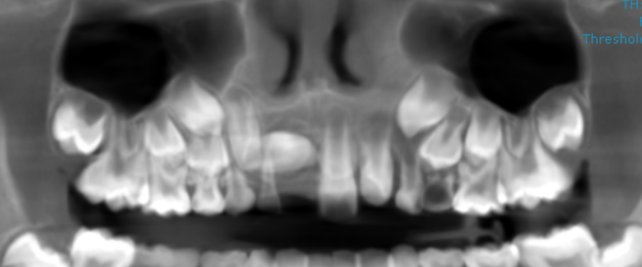
3-DIMENSIONAL VIEW

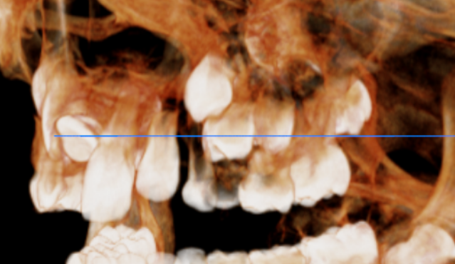
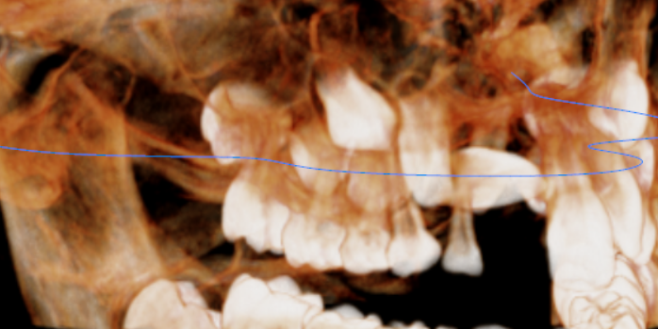
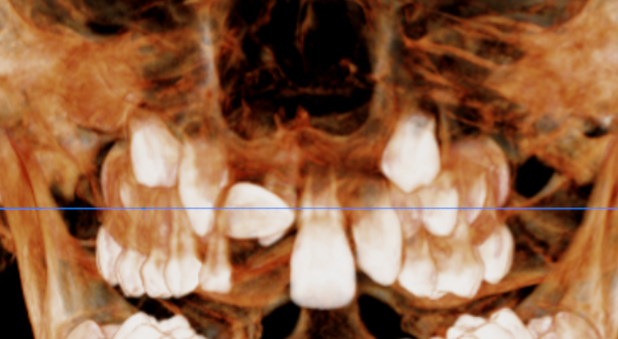
11 REGION | 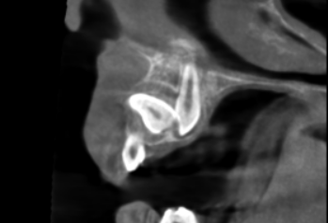  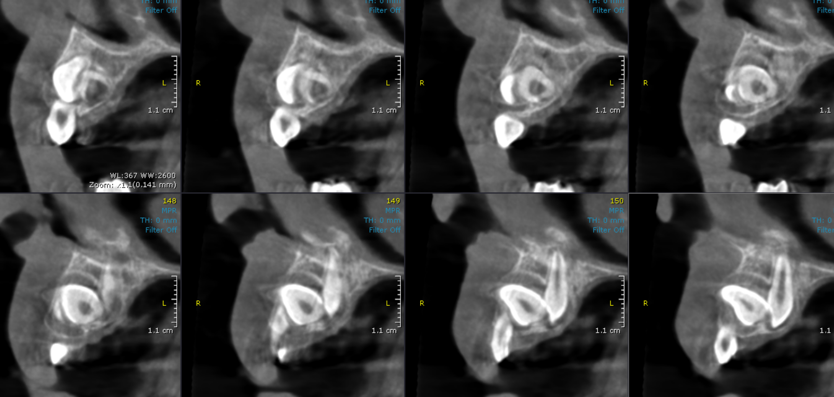
CROSS- SECTIONAL IMAGES

**** End of report ****

